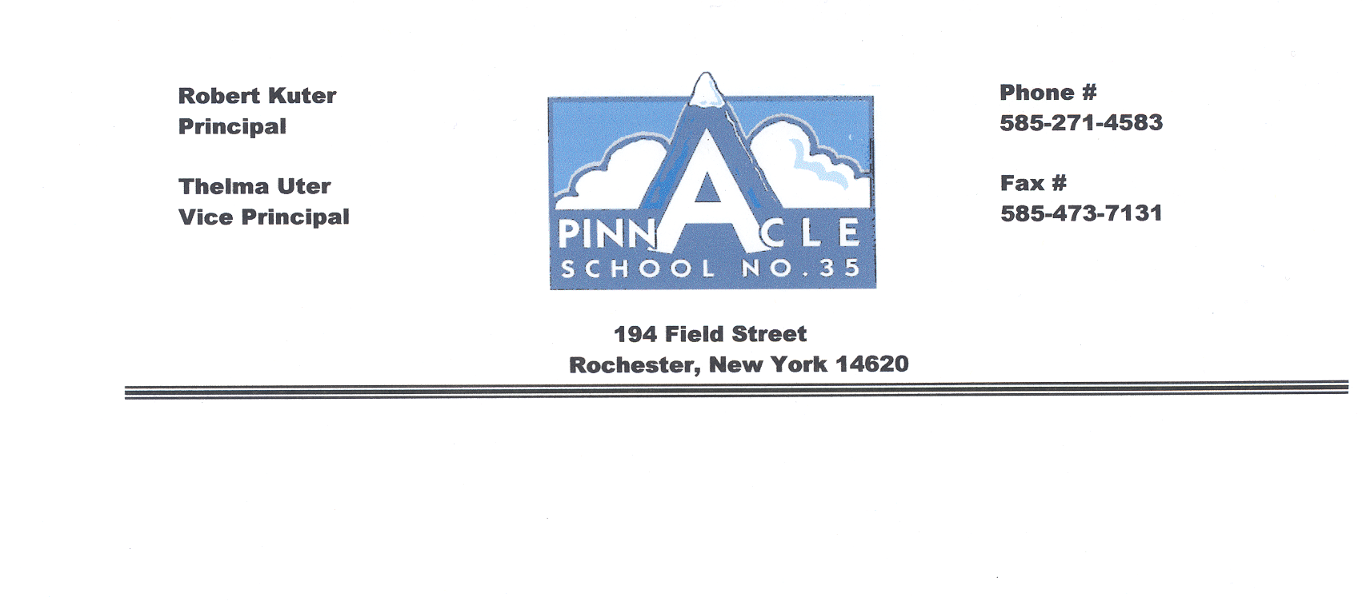
Brenda Torres-Santana
Principal

Valerie Holberton
Assistant Principal

Dear Parents or Guardian:

Now that the school year has started, it is important that we have information and appropriate approval on a few documents. Please complete the starred (*) items and send the completed forms to school with your son/daughter.

*1. Student Information Sheet: This form gives us the correct emergency information we need to
contact parents. Please make any correction and updates needed, remove any information that is not accurate.
*2. Parent School Compact: This form describes the responsibilities of Parents/Students/Staff.
This form must be read, discussed, signed by students and parents and returned to school.
*3. Field and Walking Trip Medical Consent Form: This form is consent for your child to go on
school field trips. The information on this form is checked by the nurse, who then gives
clearance for your child to participate in field trips throughout the school year.
*4. Library Permission: This form gives students permission to take books out of the library.
*5. Internet Use Policy: This is a consent allowing your child to access acceptable internet sites
following district internet policies.
*6. Photo Release form: This form gives consent to allow us to use photos we take that might
Include your child’s picture for publicity purpose.
7. Parent Involvement Policy: This is a guide for parents regarding the parent involvement at
School No. 35.
8. Lunch Applications: will be mailed out at the end of the month if you don’t receive one at
home we will have extra copies in the main office. It is a district requirement for every student
to have an application on file.
9. Parent Handbook: This is a guide for parents that contains information and procedures for No.
35 School
*Parent Handbook commitment signed and returned to school.

Please complete the forms and send them back to school with your child tomorrow. It is necessary for you to complete a form for every child in your household that attends No. 35 School. If you have any questions, please direct them to the classroom teacher @ 271-4583.

Sincerely,

Brenda Torres-Santana
Principal

